
Sukkur Institute of Business Administration University
Department of Computer Science
BS – I (CS/AI/SE) Fall 2025

Programming Fundamentals
Lab # 07: To become familiar with while loop, do while loop and nested loops

Lab Report Rubrics  (Add the points in each column, then add across the bottom row to find the total score) |  |  |  |  | Total Marks
S.No | Criterion | 0.5 | 0.25 | 0.125
1 | Accuracy | - Desired output | - Minor mistakes | - Critical mistakes
2 | Timing | - Submitted within the given time | - 1 day late | - More than 1 day late
Submission Profile
Name: Submission date (dd/mm/yy):
Enrollment ID: Receiving authority name and signature:
Comments: __________________________________________________________________________
Instructor Signature

Note: Submit this lab hand-out in the next lab with attached solved activities and exercises

Objectives
- Understand loops and create programs using them
- Understand nested loops
Loops
A loop is a program construct that repeats a statement or group of statements multiple times We write the statement/statements that are to be repeated inside the body of the loop. Each repetition of the loop is called an iteration.
There are two main categories of loops:
- Counter-controlled loops
- Sentinel-controlled loops

Counter-controlled loops
A counter-controlled loop is also known as definite repetition loop, since the number of iterations is known before the loop begins to execute.
for Loop:
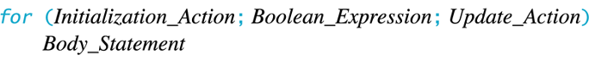
OR
Flowchart of for loop in C++

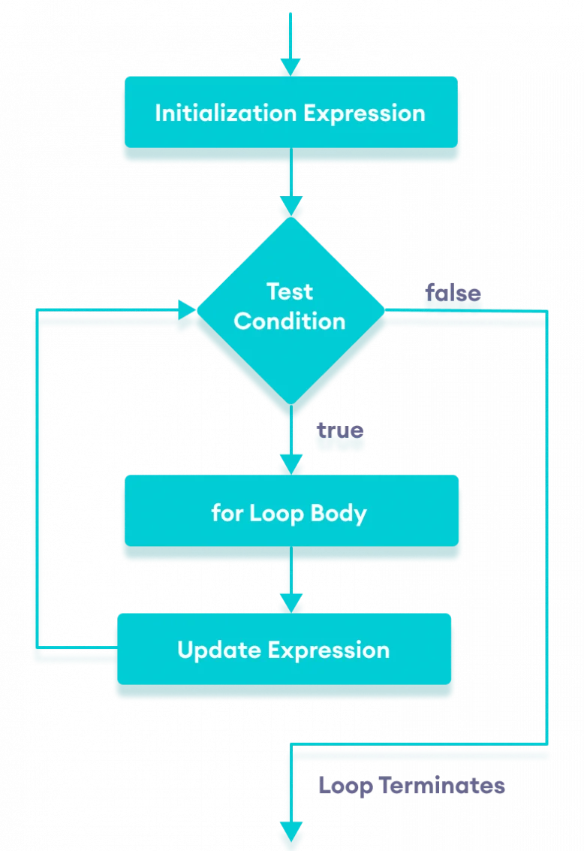
Example 1: Printing Numbers From 1 to 5
#include <iostream> using namespace std;
int main() {
for (int i = 1; i <= 5; i++) { cout << i << " "; }
return 0;}

Output:
1 2 3 4 5
Here is how this program works

Sentinel-controlled loops
A sentinel-controlled loop is also called an indefinite repetition loop because the number of iterations is not known before the loop starts executing. In a sentinel-controlled loop, a special value called sentinel value is used to change the loop control expression from true to false in order to determine whether to execute the loop body. Sentinel-controlled loop is useful when we do not know in advance how many times the loop will be executed. An example of a sentinel-controlled loop is the processing of data from a text file (or database) of unknown size. Another example could be: continuously getting an integer as input from the user and only stopping when the user has entered a zero (0).
Two common sentinel-controlled loops in C++ are:
- while loop
- do-while loop

while loop
The general syntax of while loop is:
while (condition) {
// body of the loop
}
Here
- A while loop evaluates the condition
- If the condition evaluates to true, the code inside the while loop is executed.
- The condition is evaluated again.
- This process continues until the condition becomes false.
- When the condition evaluates to false, the loop terminates.
The condition must become false at some time in the future. Otherwise, it would become an infinite loop. Therefore, some people also write the general syntax as:
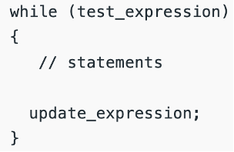
Where update_expression updates (usually increments/decrements) the loop variable being tested in the condition of the loop.
Flowchart of while loop
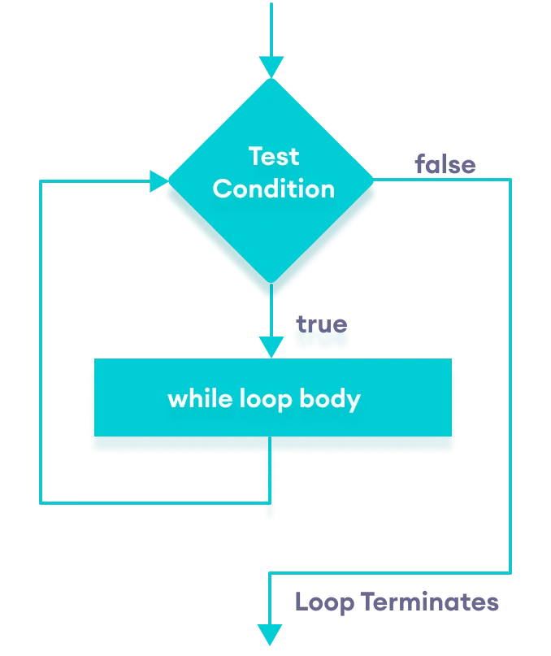

Example 2:
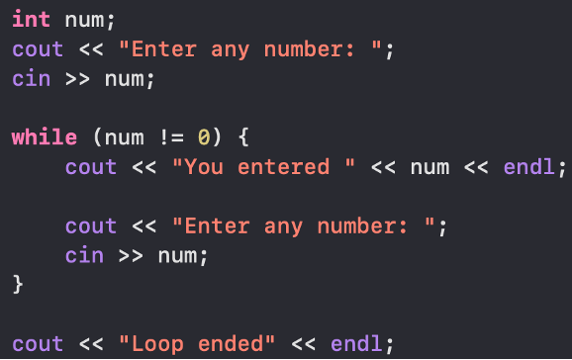
Output:

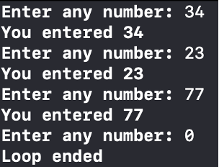

Example 3: Displaying numbers from 1 to 5
// C++ Program to print numbers from 1 to 5
#include <iostream>
using namespace std;
int main() {
int i = 1;
// while loop from 1 to 5
while (i <= 5) {
cout << i << " ";
++i;
}
return 0;
}

Output:
1 2 3 4 5

Here is how this program works

Iteration | Variable |  |  | Condition (i <= 5) | Action
1st | i | = | 1 | true | 1 is printed. i is increased to 2.
2nd | i | = | 2 | true | 2 is printed. i is increased to 3.
3rd | i | = | 3 | true | 3 is printed. i is increased to 4.
4th | i | = | 4 | true | 4 is printed. i is increased to 5.
5th | i | = | 5 | true | 5 is printed. i is increased to 6.
6th | i | = | 6 | false | The loop is terminated

Example 4: Sum of positive numbers
// program to find the sum of positive numbers
// if the user enters a negative number, the loop ends
// the negative number entered is not added to the sum

#include <iostream>
using namespace std;
int main() {
int number;
int sum = 0;

// take input from the user
cout << "Enter a number: ";
cin >> number;

while (number >= 0) {

// add the current number with previous value of sum
sum += number;

// take input again to see if the number is positive
cout << "Enter a number: ";
cin >> number;
}

// display the sum
cout << "\nThe sum is " << sum <<endl;
return 0;
}

Output:

Enter a number: 6
Enter a number: 12
Enter a number: 7
Enter a number: 0
Enter a number: -2
The sum is 25

do-while loop
The do...while loop is a variant of the while loop with one major difference: the body of do...while loop is executed once before the condition is checked. Its syntax is:
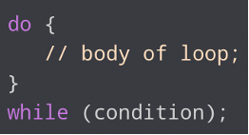

Here
- The body of the loop is executed at first. Then the condition is evaluated.
- If the condition evaluates to true, the body of the loop inside the do statement is executed again.
- The condition is evaluated once again. If the condition evaluates to true, the body of the loop inside the do statement is executed again.
- This process continues until the condition evaluates to false. Then the loop stops.

Flowchart of do-while loop
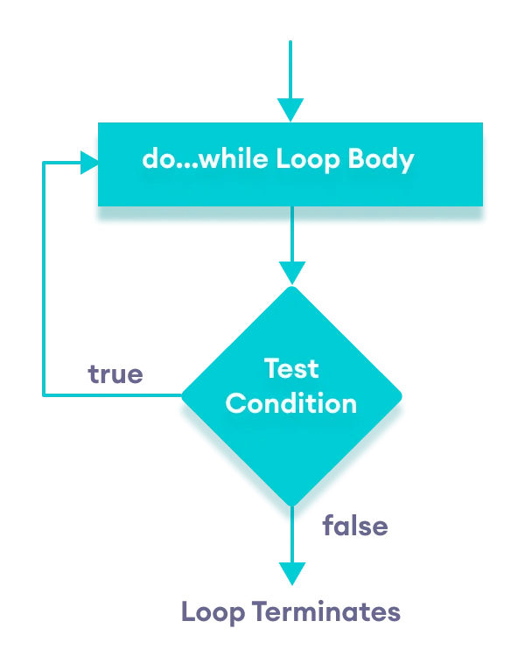

Example 5:
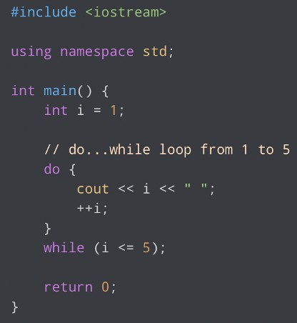
Output:
1 2 3 4 5
Here is how this program works

Iteration | Variable |  |  | Condition (i <= 5) | Action
 | i | = | 1 | not checked | 1 is printed. i is increased to 2.
1st | i | = | 2 | true | 2 is printed. i is increased to 3.
2nd | i | = | 3 | true | 3 is printed. i is increased to 4.
3rd | i | = | 4 | true | 4 is printed. i is increased to 5.
4th | i | = | 5 | true | 5 is printed. i is increased to 6.
5th | i | = | 6 | false | The loop is terminated

Loop (Repetition statement)
Loops allow you to repeat a block of code multiple times. The most commonly used loops in C++ are:
- for Loop: It is used for iterating/repeating a task for specific number of times.
for (initialization; condition; update) {
// code to be executed repeatedly while the condition is true
}

- while Loop: Repeats a block of code while a specified condition is true.
while (condition) {
// Code to repeat as long as the condition is true
}

- do-while Loop: Similar to the while loop, but it guarantees that the code block is executed at least once.
do {
// Code to repeat at least once
} while (condition);

Example: Loops
Write a program to print and sum 1 – 10 numbers.
Solution
FOR LOOP | WHILE LOOP | DO-WHILE LOOP
#include <iostream>  using namespace std;  int main()  {  int i;  int sum = 0;  for (i = 1; i <= 10; i++)  {  cout << i << " ";  sum = sum + i;  }  cout << endl<< endl << sum;  return 0;  } | #include <iostream>  using namespace std;  int main()  {  int i;  int sum = 0;  while(i<=10)  {  cout<<i<<" ";  sum = sum + i;  i++;  }  cout << endl<< endl << sum;  return 0;  } | #include <iostream>  using namespace std;  int main()  {  int i;  int sum = 0;  do  {  cout<<i<<" ";  sum = sum + i;  i++;  } while(i<=10);  cout << endl<< endl << sum;  return 0;  }

Practice Exercise 1 (Simple for loop)
#include <iostream>
using namespace std;
int main() {

//Loop to print the hello 10 times
for (int i=1; i<=10;i++){
cout <<”Hello”;
}
//Loop to print the * 10 times
for (int i=1; i<=10;i++){
cout <<”*”;
}
//Loop to print the * 10 times on different line
for (int i=1; i<=10;i++){
cout <<”*”<<endl;
}
//Loop to print the whole Numbers
for (int i=1; i<=10;i++){
cout <<i<<endl;
}
//Loop to print the Even Numbers
for (int i=0; i<=10;i+=2){ cout <<i<<endl;
}
}

Practice Exercise 2 (Input validation using if)
#include <iostream> using namespace std;

int main() {
int height, marks;

//Height input and Validation cout << "Enter the height : "; cin >> height;
if (height <= 0) {
cout << "Please enter a positive integer for the height" << endl; return 1; // Exit the program with an error code
}

//Marks input and validation
cout << "Enter the Marks : "; cin >> marks;

if ( marks<0 || marks>100 ) {
cout << "Please enter the valid value of Marks" << endl; return 1; // Exit the program with an error code
}
//ANother way to check the valid marks using negation if ( !(marks>=0 && marks<=100) ) {
cout << "Please enter the valid value of Marks" << endl; return 1; // Exit the program with an error code
}
}

Practice Exercise 3 (Input validation using while)
#include <iostream> using namespace std;

int main() {

int height, marks;

//Height input and Validation cout << "Enter the Marks: "; cin >> marks;

//ANother way to check the valid marks using negation while ( !(marks>=0 && marks<=100) ) {
cout << "Please enter the valid value of Marks" << endl; cin >> marks;
}
cout <<"You entered " <<marks;
}

Practice Exercise 4 (Input validation using do-while)
#include <iostream> #include <iomanip> using namespace std;

int main() {
int height=-1, marks=-1;

//ANother way to check the valid marks using negation do {
cout << "Please enter the valid value of Marks" << endl; cin >> marks;
} while ( !(marks>=0 && marks<=100) ); cout <<"You entered " <<marks;
}

Practice Exercise 5(CONTINUE/EXIT)
Write a program to ask user NAME and print “Welcome Dear [NAME]”, then ask user whether user wants to continue or exit (y → continue, e → exit). Print an appropriate message to tell user how to EXIT/CONTINUE.
Note: In following each task, you have to ask user whether CONTINUE/EXIT, if continues then the program should RUN AGAIN otherwise TERMINATE.

Solutions
/*Practice Exercise 5(CONTINUE/EXIT) Ask user whether CONTINUE/EXIT,
ask user whether user wants to continue or exit (y ' continue, e ' exit).
if continues then the program should RUN AGAIN otherwise TERMINATE.
*/
#include <iostream> using namespace std; int main(){
string name; //variable declaration for input name
char choice; //variable to take user choice for exit or continue

do{
cout << "Enter your name: ";
fflush(stdin);
getline (cin, name);
cout << "Welcome Dear " << name << endl;
cout << "Do you want to continue, Press y to continue and e to exit "; cin >> choice;
cout <<endl;
} while( choice == 'y'); //loop will continue when user choice is y

return 0;
}

Practice Exercise 6(Continue, break, and exit keywords)
Write a program to demonstrate the use of continue, break, exit, and return keywords.

Solutions
#include <iostream> using namespace std;
int main(){
//Use of continue keyword for (int i=1; i<=10; i++){
cout <<endl; cout <<"Hello"; if (i%4==0)
continue;//will skip the next statements of current iteration cout << i;
}
cout << endl << "This statement is outside the first loop" << endl << endl;

//Use of break keyword
for (int i=1; i<=10; i++){
cout <<endl;
cout <<"Hello";
if (i%4==0)
break; //Continue will break the execution of loop and control will be shifted to the lines afer loop body
cout << i;
}
cout << endl << "This statement is outside the second loop" << endl;

//Use of exit keyword
for (int i=1; i<=10; i++){ cout <<endl;
cout <<"Hello"; if (i%4==0)
exit(0); //Continue will break the execution of loop and control will be shifted to the lines after loop body
cout << i;
}

cout << endl << "This statement is outside the third loop" << endl;

//Use of exit keyword
for (int i=1; i<=10; i++){ cout <<endl;
cout <<"Hello" << endl;
}

cout << endl << "This statement is outside the fourth loop" << endl;

return 0;
}

Nested Loops
A nested loop is a loop that appears inside another loop. A clock is a good example of something that works like a nested loop. The seconds’ hand, minutes’ hand, and hours’ hand all spin around the face of the clock. Each time the hour hand increments, the minute hand increments 60 times. Each time the minute hand increments, the second-hand increments 60 times.
Here is a program segment with a for loop that partially simulates a digital clock. It displays the seconds from 0 to 59:
for (int seconds = 0; seconds < 60; seconds++) { cout << seconds << endl;
}

We can add a minutes variable and nest the loop above inside another loop that cycles through 60 minutes (or that minutes’ loop):
for (int minutes = 0; minutes < 60; minutes++) {
for (int seconds = 0; seconds < 60; seconds++) { cout << minutes << ":" << seconds << endl;
}
}

To also consider/add hours, we can add another loop to denote the hours and put these two (nested) loops inside that third loop to make another level of nesting (or create three nested loops).
for (int hours = 0; hours < 24; hours++) {
for (int minutes = 0; minutes < 60; minutes++) {
for (int seconds = 0; seconds < 60; seconds++) { cout<<hours <<":"<< minutes <<":"<< seconds << endl;
}
}
}

The innermost loop will iterate 60 times for each iteration of the middle loop. The middle loop will iterate 60 times for each iteration of the outermost loop. When the outermost loop has iterated 24 times, the middle loop will have iterated 1,440 times and the innermost loop will have iterated 86,400 times
Following are some of the points related to nested loops
- An inner loop goes through all of its iterations (or runs from beginning to end) for each/one iteration of an outer loop.
- Inner loops complete their iterations faster than outer loops.
- To get the total number of iterations of an inner-most loop, multiply the number of iterations of all the loops.
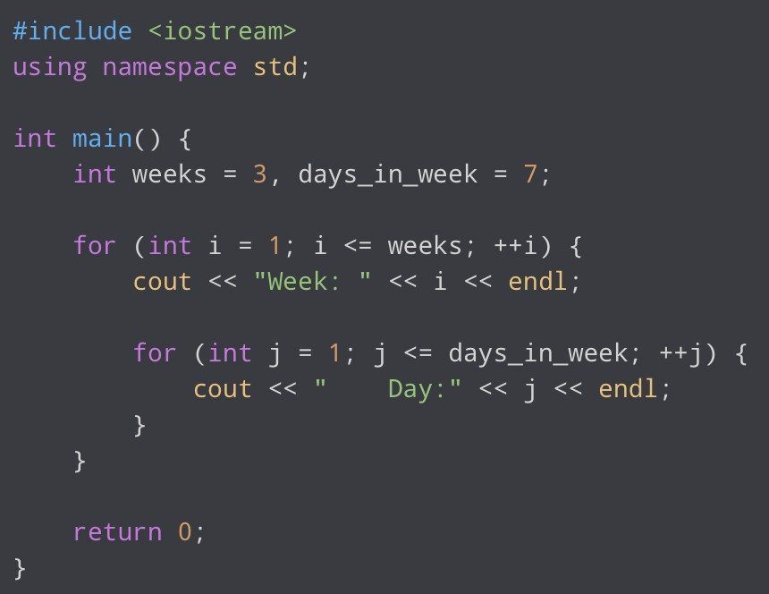
Another example could be looping through each day of a week. Suppose we want to loop through each day of a week for 3 weeks. To achieve this, we can create a loop to iterate three times (3 weeks let suppose in this example). And inside that loop, we can create another loop to iterate 7 times (to denote 7 days of a week), as shown below.

Output:
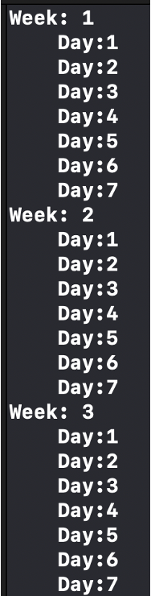
Imagine we are required to print the asterisks “*” in the pattern shown below
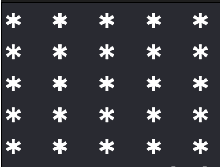
We can use nested loops to do so. One loop will represent rows and one loop will denote columns
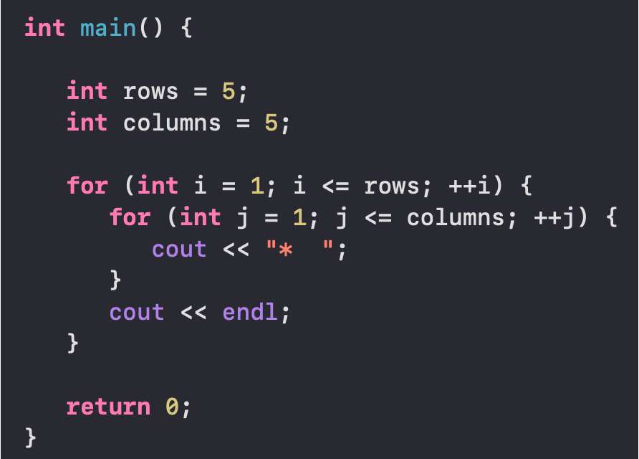

Exercises of While and Do while Loop:
- Write a C++ program that should continuously ask the user to input any integer number until and unless a negative number is entered. When a negative number is entered, then the program should end and print the sum of all the entered numbers.
However, it should also check that large numbers (greater than 30) should not be considered for calculating the sum, like shown below:

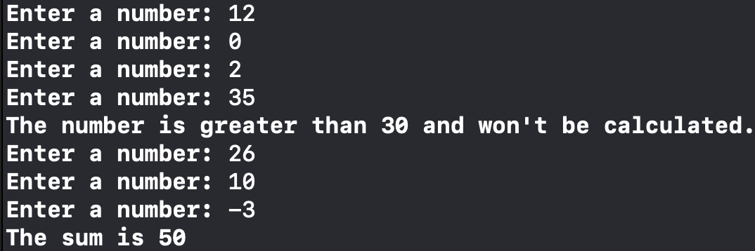

- Write a C++ program that receives the total number of integers (N) from the user. Then, the program will ask the user for N real numbers. By applying for loop, your program should find and display the largest and the lowest of the numbers. Give a proper message for invalid user input, as shown below:

#Sample Program Run#1
How many numbers do you have? > -3 Sorry, you have entered an invalid input. Thank You.

#Sample Program Run#2
How many numbers do you have? > 0
Opps, you don't have any number for me to process. Thank You.

#Sample Program Run#3
How many numbers do you have? > 5 Please enter a number_1 --> 12.5
Please enter a number_2 --> -3.2
Please enter a number_3 --> 0
Please enter a number_4 --> 5 Please enter a number_5 --> 8.5

The lowest number is -3.20
The highest number is 12.50 Thank You.

- Create a Guessing Game program, where you will guess a number. For now, assume any fixed number of choices as the actual number to be guessed (means, hardcode that value inside the code). Then, continuously ask the user to guess the number (I.e., input the number) unit and unless he/she guesses it correctly.
Display the message(s) to the user as described below:
- If the entered number is smaller than the actual number, then you should display a message saying the user that his/her entered number is smaller than the actual number
- If the entered number is greater than the actual number, then you should display a message saying the user that his/her entered number is greater than the actual number
- If the user guesses the number correctly (I.e., enters the actual number), then display a Congrats message, as shown below:

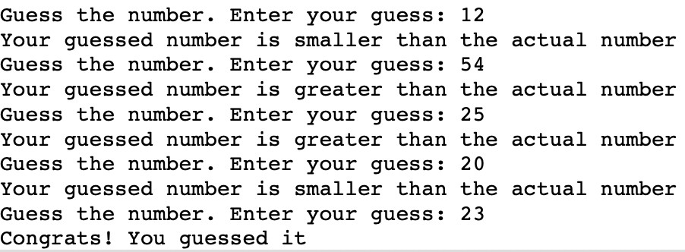

- Extend the Guessing Game program created above. Other rules are the same as stated in the previous part. However, in this program, the actual number’s value should be fixed between 1 and 100 and the user should be allowed only five (05) attempts.
If the user guesses the number within five attempts, then display a Congrats message. Otherwise, the program should end after five wrong attempts, and display a sorry message to the user and the actual number as well.

- Create a program for a simple shopping application, where a user will be shown a Menu from which he/she can select any product to purchase or enter zero (0) to exit the program as shown below:
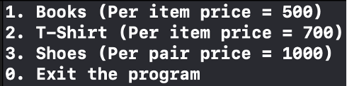

As shown above, each product will also show its cost per item in the brackets.
That Menu should be continuously shown to the user (so that the user can select multiple products (OR even the same product again) until and unless the user enters a zero (0), like

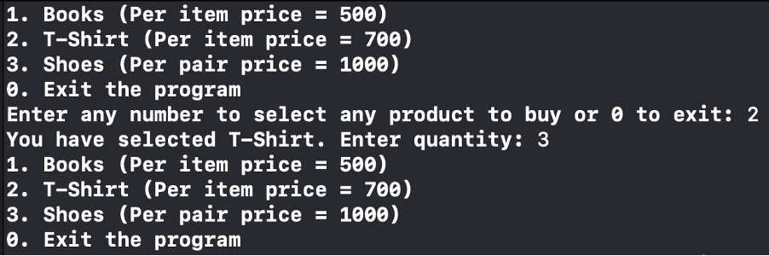

When the user selects any product, then the program should ask the user to input the desired quantity of that product to be bought, as shown in the image above.

As discussed earlier, this process should continue and the user should be shown the Menu again and again so that he/she may select multiple products.
Finally, when the user enters a zero (0) to exit the program, then a detailed description should be shown that should include
- all the purchase products
- their quantity (for each product)
- the subtotal cost (of each product bought)
- and the total cost (of all the products)

A sample working is shown in the following image:

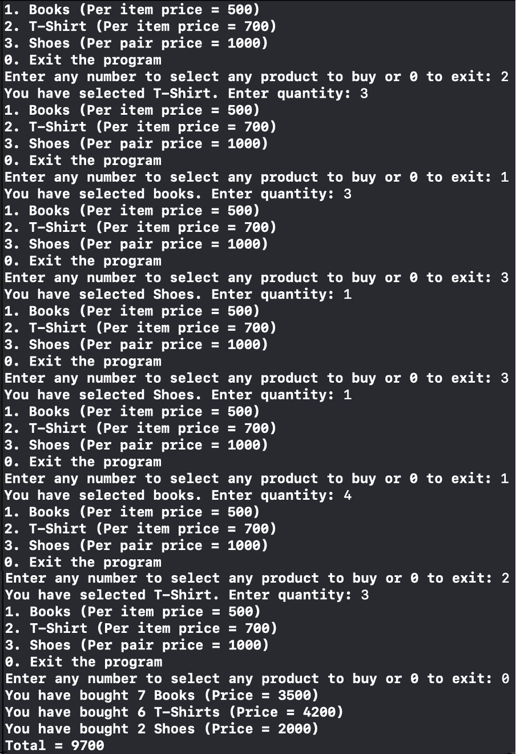
Exercises of Nested Loops:

- Using nested loops, write separate C++ programs to generate each of the following outputs.

(i) | 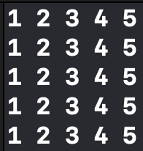 | (ii) | 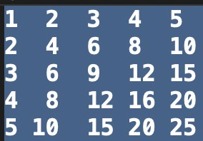
(iii) | 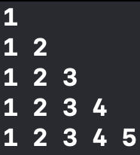 | (iv) | 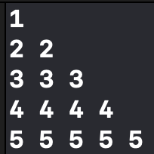
(v) | 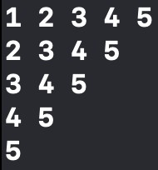 | (vi) | 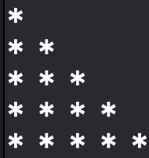
(vii) |  | (viii) | 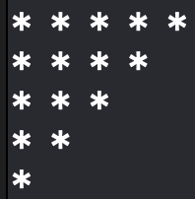
(ix) | 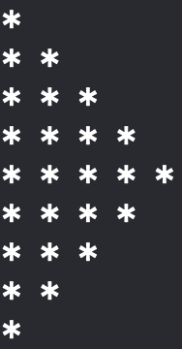 | (x) | 

- Write a program that computes average test scores of students. The program should first ask the user to input total number of students and then the number of test scores per student. After that, for each student, ask the user to enter test scores and compute (and display) the average test score of every student, as shown in the sample output below:
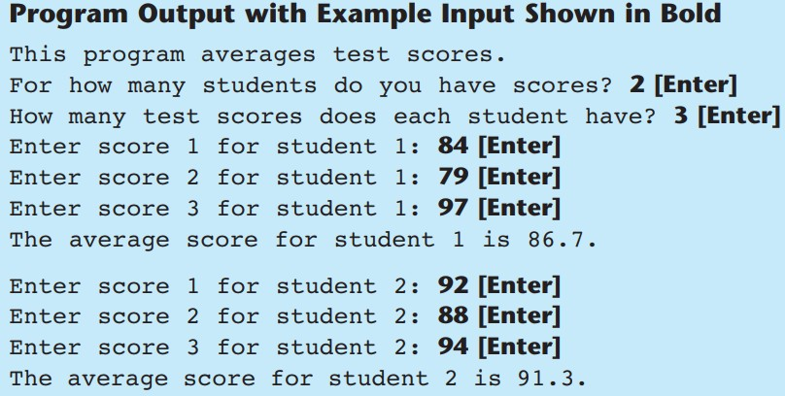
- Write a program that asks the user to input an integer value that denotes the range up to which tables of number should be printed. Then, tables of all the numbers from 1 to that range value should be displayed, as shown below:
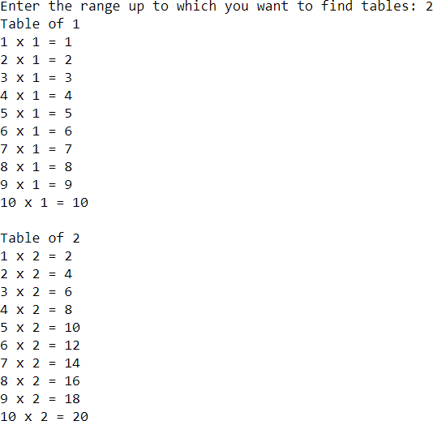
Here, the user has entered the value 2. That is why tables of only 1 and 2 are displayed. But if the user enters 5 as the range value, then tables of all numbers 1, 2, 3, 4, and 5 should be displayed in the way shown above.

